**Healthy Life Insurance Charges MySQL QUERY DOCUMENT**

**Insurance Charges REPORT | SUMMARY : BY Shivanand S Nashi**

**1. Total insurance charges across all individuals:**

**SELECT SUM(charges) AS total_charges FROM insurance;**

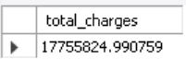

**2. Average charges by gender:**

**SELECT sex, AVG(charges) AS average_charges**

**FROM insurance GROUP BY sex ORDER BY average_charges DESC;**

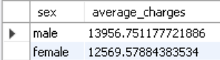

**3. Top 10 highest charges:**

**SELECT * FROM insurance ORDER BY charges DESC LIMIT 10;**

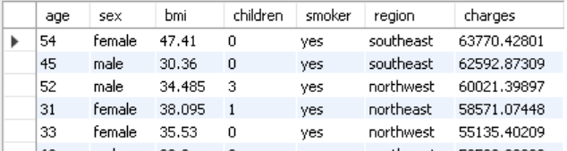

**4. Count of individuals based on smoking status:**

**SELECT smoker, COUNT(*) AS count FROM insurance GROUP BY smoker;**

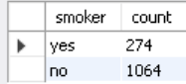

**5. Average BMI by region:**

**SELECT region, AVG(bmi) AS average_bmi**

**FROM insurance**

**GROUP BY region**

**ORDER BY average_bmi DESC;**

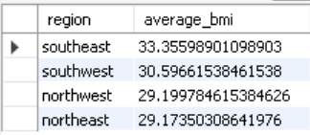

**6. Region contributing the highest total charges:**

**SELECT region, SUM(charges) AS total_charges**

**FROM insurance GROUP BY region ORDER BY total_charges DESC LIMIT 1;**



**7. Number of individuals with BMI greater than 30 (indicating obesity):**

**SELECT COUNT(*) AS obese_count FROM insurance WHERE bmi > 30;**

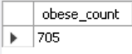

**8. Correlation between the number of children and charges:**

**SELECT children, AVG(charges) AS average_charges**

**FROM insurance GROUP BY children ORDER BY average_charges DESC;**

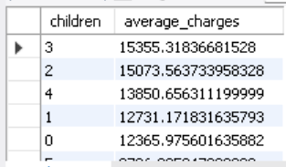

**9. Percentage of smokers in the dataset:**

**SELECT (COUNT(*) * 100.0 / (SELECT COUNT(*) FROM insurance)) AS smoker_percentage**

**FROM insurance WHERE smoker = 'yes';**



**10. Age group with the highest average charges:**

**SELECT CASE**

**WHEN age BETWEEN 18 AND 25 THEN '18-25'**

**WHEN age BETWEEN 26 AND 35 THEN '26-35'**

**WHEN age BETWEEN 36 AND 45 THEN '36-45'**

**WHEN age BETWEEN 46 AND 55 THEN '46-55'**

**ELSE '56+'**

**END AS age_group,**

**AVG(charges) AS average_charges**

**FROM insurance GROUP BY age_group ORDER BY average_charges DESC;**

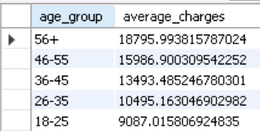

**11. Effect of smoking on charges (smokers vs. non-smokers):**

**SELECT smoker, AVG(charges) AS average_charges**

**FROM insurance GROUP BY smoker ORDER BY average_charges DESC;**

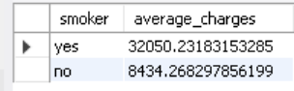

**12. Top 5 individuals with the highest BMI:**

**SELECT * FROM insurance ORDER BY bmi DESC LIMIT 5;**

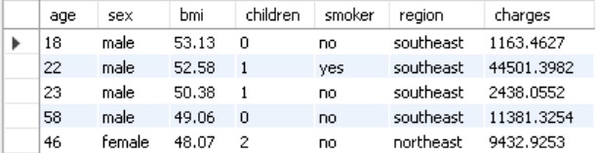

**13. Region with the highest percentage of smokers:**

**SELECT region,**

**(COUNT(CASE WHEN smoker = 'yes' THEN 1 END) * 100.0 / COUNT(*)) AS smoker_percentage**

**FROM insurance GROUP BY region ORDER BY smoker_percentage DESC LIMIT 1;**

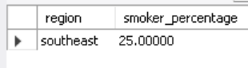

**14. Average charges for individuals with and without children:**

**SELECT CASE**

**WHEN children > 0 THEN 'With Children'**

**ELSE 'No Children'**

**END AS category,**

**AVG(charges) AS average_charges**

**FROM insurance GROUP BY category;**

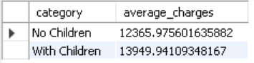

**15. Gender-wise count of smokers:**

**SELECT sex, smoker, COUNT(*) AS count FROM insurance GROUP BY sex, smoker ORDER BY sex, smoker;**

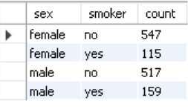

**16. Age and charges relationship for smokers:**

**SELECT age, AVG(charges) AS average_charges**

**FROM insurance WHERE smoker = 'yes' GROUP BY age ORDER BY average_charges DESC;**

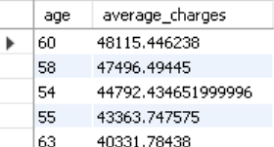

**17. Identify individuals who are likely overweight (BMI > 25) but have low charges (< $5,000):**

**SELECT * FROM insurance WHERE bmi > 25 AND charges < 5000;**

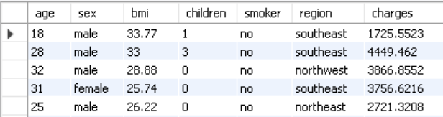

**18. Highest charges in each region by smoker status:**

**SELECT region, smoker, MAX(charges) AS highest_charges**

**FROM insurance GROUP BY region, smoker ORDER BY region, smoker;**

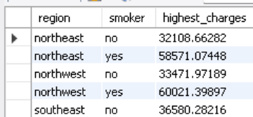

**19. Distribution of individuals by BMI categories (Underweight, Normal, Overweight, Obese):**

**SELECT CASE**

**WHEN bmi < 18.5 THEN 'Underweight'**

**WHEN bmi BETWEEN 18.5 AND 24.9 THEN 'Normal'**

**WHEN bmi BETWEEN 25 AND 29.9 THEN 'Overweight'**

**ELSE 'Obese'**

**END AS bmi_category,**

**COUNT(*) AS count**

**FROM insurance GROUP BY bmi_category ORDER BY count DESC;**

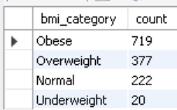

**20. Top 5 oldest individuals with the highest insurance charges:**

**SELECT * FROM insurance ORDER BY age DESC, charges DESC LIMIT 5;**

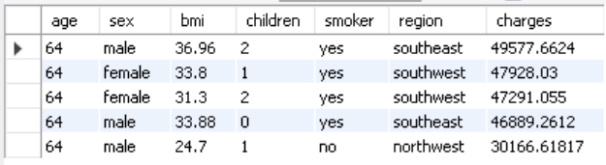

**21. Average charges by gender and smoking status:**

**SELECT sex, smoker, AVG(charges) AS average_charges**

**FROM insurance GROUP BY sex, smoker ORDER BY sex, smoker;**

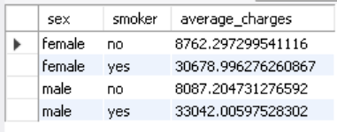

**22. Effect of having children on charges for smokers and non-smokers:**

**SELECT smoker,**

**CASE**

**WHEN children > 0 THEN 'With Children'**

**ELSE 'No Children'**

**END AS category,**

**AVG(charges) AS average_charges**

**FROM insurance GROUP BY smoker, category ORDER BY smoker, category;**

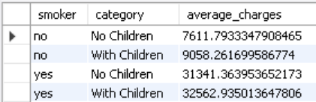

**23. Identify regions where individuals with BMI > 30 have the highest average charges:**

**SELECT region, AVG(charges) AS average_charges**

**FROM insurance WHERE bmi > 30 GROUP BY region ORDER BY average_charges DESC;**

